Graph Labeling

Greg Netols

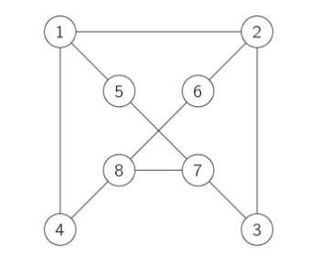

My solution involved setting each edge to one of the first 10 prime numbers [2,3,5,7,11,13,17,19,23,29]. Then setting each node to the product of all connected edges. I created a quick python script to search through all the permutations to identify the minimum sum. Below are my node values and total sum of all nodes.

Node1: 406

Node2: 494

Node3: 299

Node4: 119

Node5: 145

Node6: 209

Node7: 345

Node8: 561

Total Sum: 2578